**AMERICAN UNIVERSITY OF SCIENCE & TECHNOLOGY**

DEPARTMENT OF COMPUTER AND COMMUNICATIONS ENGINEERING



**CSI345L**

Enterprise Infrastructure Project

Prepared by:

Fouad Dakhoul (12210449)

Youssef Chayeb (12210624)

Mohamad Madi (12203006)

Yaakoub khalil (12200055)

Submitted to:

Dr Gaby Abou Haidar

Beirut, Lebanon

June, 2022

# Abstract

In an information system, networking, often known as computer networking, is the activity of transferring and exchanging data between nodes through a shared media. Devices and endpoints can be connected to each other on a local area network (LAN) or to a larger network, such as the internet or a private wide area network, using computer networking (WAN). Service providers, enterprises, and consumers all across the world rely on this function to share resources, use or sell services, and communicate. Everything from phone conversations to text messaging to streaming video to the internet of things is made easier with networking.

In our project we worked on a company called Clean Energy (CE), it has a main head office and several branches, these branches are connected with different type of connections and using different protocols, we divided our company into different VLANS to make sure the integrity of information.

# Table of contents

Contents

Abstract 2

Table of contents 3

List of Figures 4

List of Tables 5

Introduction 6

Design 7

IP addresses 8

Network Details: 9

Conclusion 9

# List of Figures

Figure 1: Network Design 7

List of Tables

Table 1: IP addresses 8

# Introduction

The complexity of a network is directly proportional to the level of skill necessary to operate it. For example, a major corporation may have hundreds of nodes and stringent security needs, such as end-to-end encryption, necessitating the supervision of expert network managers.

Clean Energy is a company based in Achrafieh has a duty to install solar system in different area in Lebanon with different sub-offices in different regions across the country and to ensure the best quality of communication between all offices a network design is a must and should be secure with several protocols, because this company communicate with manufacturer located outside so the security is high demand.

The Vlans listed (IT office, users, servers, management, DMZ servers) are located in the main branch of the company and each of the is assigned by specific IP address. The vlans configured in both HO and branch in order to provide maximum security and isolation, to help prevent attackers and unwanted users from internal and external attacks. The vlans configured in both HO and branch in order to provide maximum security and isolation, to help prevent attackers and unwanted users from internal and external attacks

# Design

Figure : Network Design

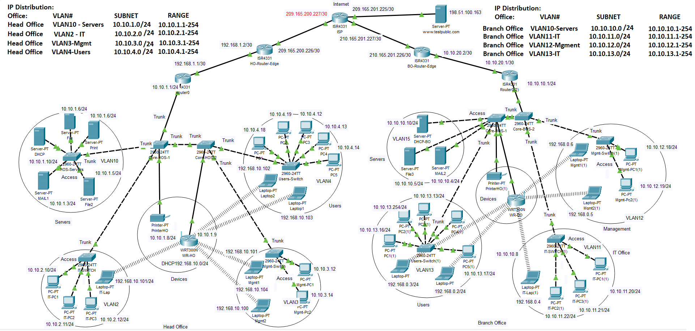

# IP addresses

|  |  |  |  |  |
| --- | --- | --- | --- | --- |
| Location | Name | Subnet ID | Host Addresses | Subnet Broadcast |
| Head office | HO server VLAN1 | 10.10.1.0 | 10.10.1.1 - 10.10.1.254 | 10.10.1.255 |
| IT VLAN2 | 10.10.2.0 | 10.10.2.1 - 10.10.2.254 | 10.10.2.255 |
| VLAN3 | 10.10.3.0 | 10.10.3.1 - 10.10.3.254 | 10.10.3.255 |
| VLAN4 | 10.10.4.0 | 10.10.4.1 - 10.10.4.254 | 10.10.4.255 |
| Future use | 10.10.5.0 | 10.10.5.1 - 10.10.5.254 | 10.10.5.255 |
| Future use | 10.10.6.0 | 10.10.6.1 - 10.10.6.254 | 10.10.6.255 |
| Future use | 10.10.7.0 | 10.10.7.1 - 10.10.7.254 | 10.10.7.255 |
| Future use | 10.10.8.0 | 10.10.8.1 - 10.10.8.254 | 10.10.8.255 |
| Future use | 10.10.9.0 | 10.10.9.1 - 10.10.9.254 | 10.10.9.255 |
| Branch office | BO server | 10.10.10.0 | 10.10.10.1 - 10.10.10.254 | 10.10.10.255 |
| IT VLAN11 | 10.10.11.0 | 10.10.11.1 - 10.10.11.254 | 10.10.11.255 |
| VLAN12 | 10.10.12.0 | 10.10.12.1 - 10.10.12.254 | 10.10.12.255 |
| VLAN13 | 10.10.13.0 | 10.10.13.1 - 10.10.13.254 | 10.10.13.255 |
| Future use | 10.10.14.0 | 10.10.14.1 - 10.10.14.254 | 10.10.14.255 |
| Future use | 10.10.15.0 | 10.10.15.1 - 10.10.15.254 | 10.10.15.255 |
| Future use | 10.10.16.0 | 10.10.16.1 - 10.10.16.254 | 10.10.16.255 |
| Future use | 10.10.17.0 | 10.10.17.1 - 10.10.17.254 | 10.10.17.255 |
| DMZ Servers | Website1 | 192.168.10.0 | 192.168.10.223/24 |  |
|  | Website2 |  | 192.168.10.222/24 |  |
| Wireless DHCP HO | WR-HO | 192.168.10.0 | 192.168.10.10-50 |  |
| Wireless DHCP BO | WR-BO | 192.168.0.0 | 192.168.0.10-50 |  |
| ISP | IP1 | 209.165.200.0 | 209.165.200.227 |  |
|  | IP2 | 209.165.201.0 | 209.165.201.225 |  |
| Public ServerIP | [www.testpublic.com](http://www.testpublic.com) | 198.51.100.0 | 198.51.100.1 |  |
| HO-Router-Edge |  | 209.165.200.0 | 209.165.200.226 |  |
| BO-Router-Edge |  | 209.165.201.0 | 209.165.201.226 |  |

Table : IP addresses

# 

# Network Details:

We have created an Enterprise network, that simulates a real enterprise setup.

The setup consists of a Head Office, and Branch office, interconnected using back to back secure routers throughout the ISP link.

In each branch, we have created several offices (ex: Management, IT, Users, Servers etc..). All secured using different VLANs.

A DMZ sperate network has also been configured, to secure the website.

First level routers have been configured as NAT, to connect the internal users to the internet.

Edge routers have been configured to route internal router traffic to the internet and to the branch office.

A secure wireless setup has been configured, for each office, using WPA2 encryption and password.

A DHCP server is configured to provide IP addresses for the computers, while the servers have been provided with Static IP Addresses.

Redundant switches configured in each office, to provide the maximum service availability to the users.

# Conclusion

Simulating a real Enterprise infrastructure setup, using Packet Tracer, provided us the mean and hands on experience, about how a real-world setup would be configured and utilized.

From the smallest two pcs connectivity, to the extended large enterprise setup, this project gave us the opportunity to work and achieve a high-level exposure and experience in the world of networking.